|  |  |  |  |
| --- | --- | --- | --- |
| 1 | | 6,096.0 | |
| NUMERO DE FRONTERAS | | ENERGIA AGREGADA | |
|  | | | |
| SI | | 04/09/2020 | |
| CONTRATO | | VENCIMIENTO CONTRATO | |
|  | | | |
| 2,116,785 | 15 | | 91,418 |
| INGRESO 2021 | DÍAS CERTIFICADOS 2021 | | ENERGIA RESPALDADA 2021 |



|  |
| --- |
| **ESTELAR FONTANA**  USUARIO |

|  |
| --- |
| Ejecutivo de cuenta |

|  |
| --- |
| PUNTO FOCAL |

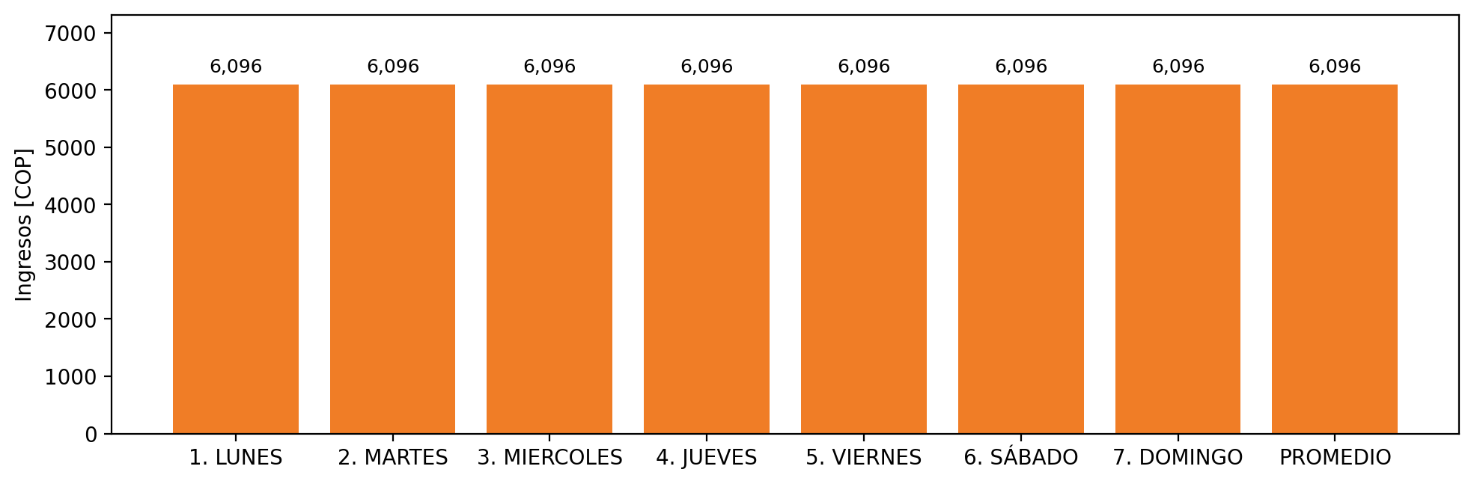

|  |  |  |  |  |  |  |  |  |  |  |
| --- | --- | --- | --- | --- | --- | --- | --- | --- | --- | --- |
| **FRONTERA** | **COD SIC** | **PREDIO** | **FRT DDV** | **TIPO DDV** | **PROMEDIO** | **PRÓXIMA ACTUALIZACIÓN** | **MARGEN DE ERROR** | **ÚLTIMA PRUEBA DDV** | **DÍAS PARTICIPACIÓN** | **FECHA REFERENCIA PRÓXIMA PRUEBA DDV** |
| ESTELAR BOGOTA | Frt00920 | Prd01700 | Frt36999 | GPE | 6,096 | 2023-04-15 | NO APLICA | 2021-09-03 | 15.0 | 2022-01-20 |